**PROJECT REPORT**

**1.INTRODUCTION**

***1.1. OVERVIEW: Generally , house price prediction can help the developer to determine the selling price of a house and can help the customer to arrange the right time to purchase a house.***

***To help people find their own homes And the fact that did not change is that Mukesh Ambani house ,Antilia , is the most expensive property in India.***

***1.2. PURPOSE:***

People are enabled to get a required housings, and are supposed to get with a affordable prices.

It helps people to get more connected with housing knowledge.

**2.PROBLEM DEFINITION & DESIGN THINKING:**

**2.1. EMPATHY MAP**

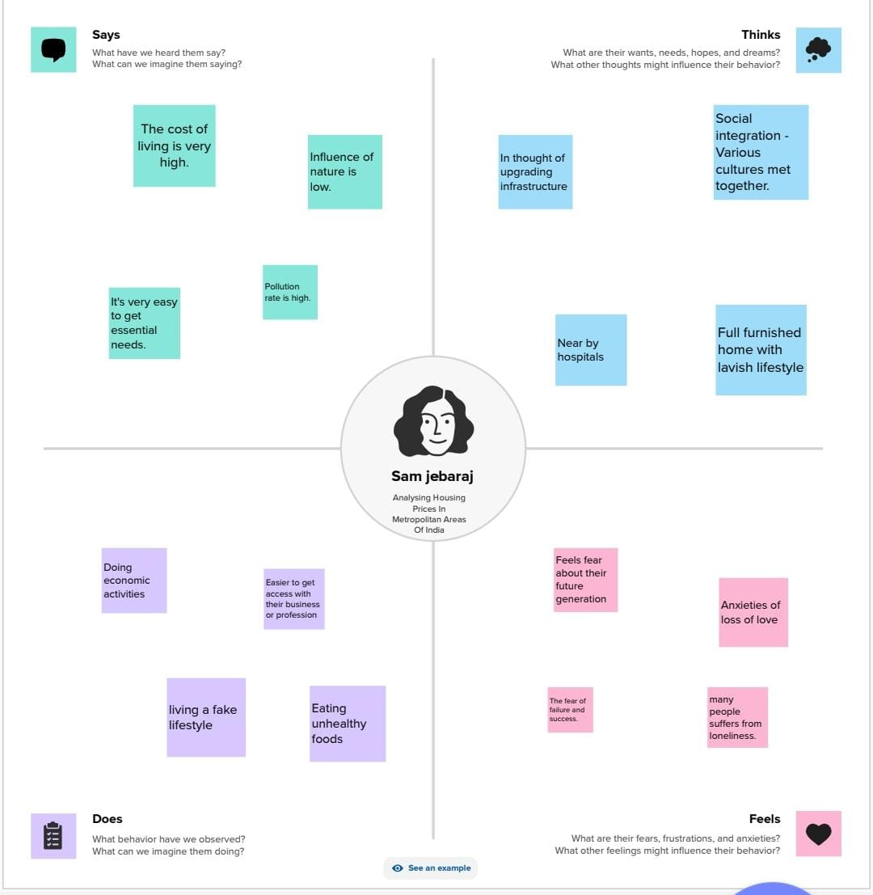

**2. IDEATION 2.& BRAINSTORMING MAP**

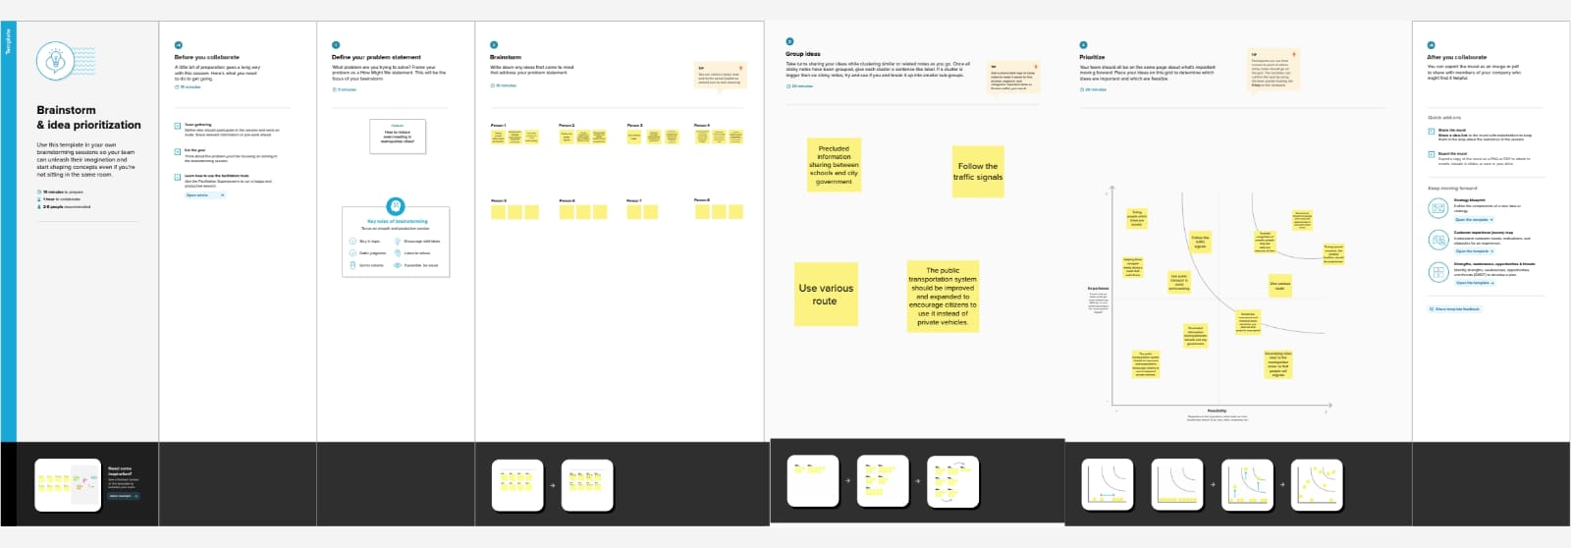

**3.DATASET**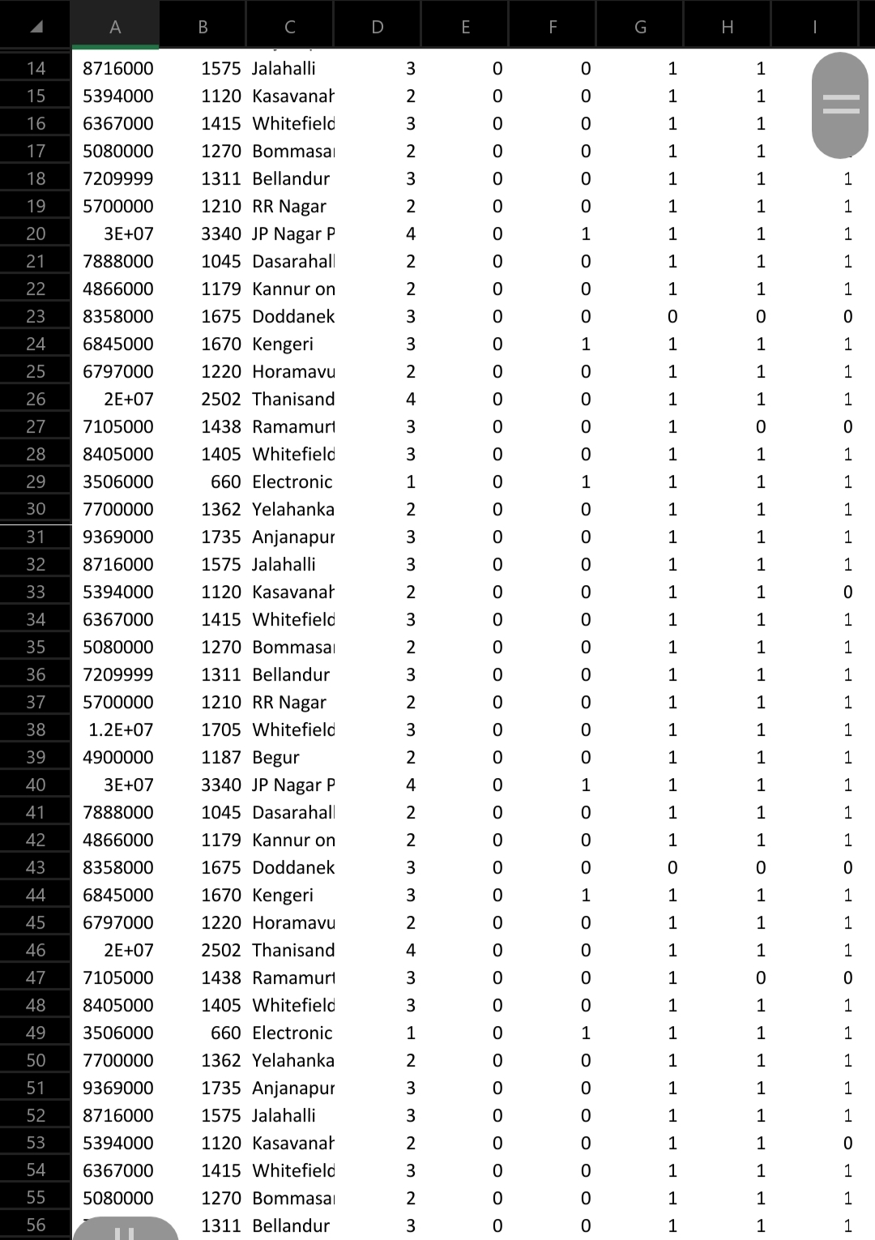

**4.ABOUT THE DATASET**

* The prices in metropolitan areas may varies by the

industrial development.

* Cost of living is high in very urbanized cities like Mumbai

where states like Ahmedabad has a very low cost of living in India.

* It also depends upon the infrastructure and facilities

provided by the builders to their Customers.

**5.DASHBOARD**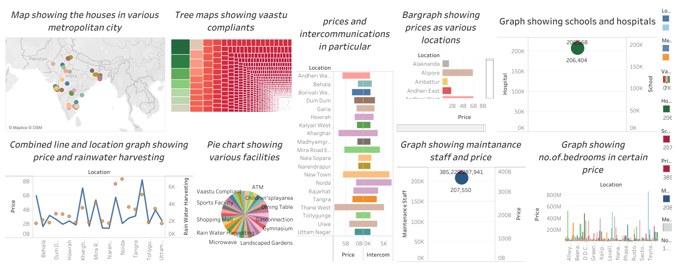

**6.STORY**

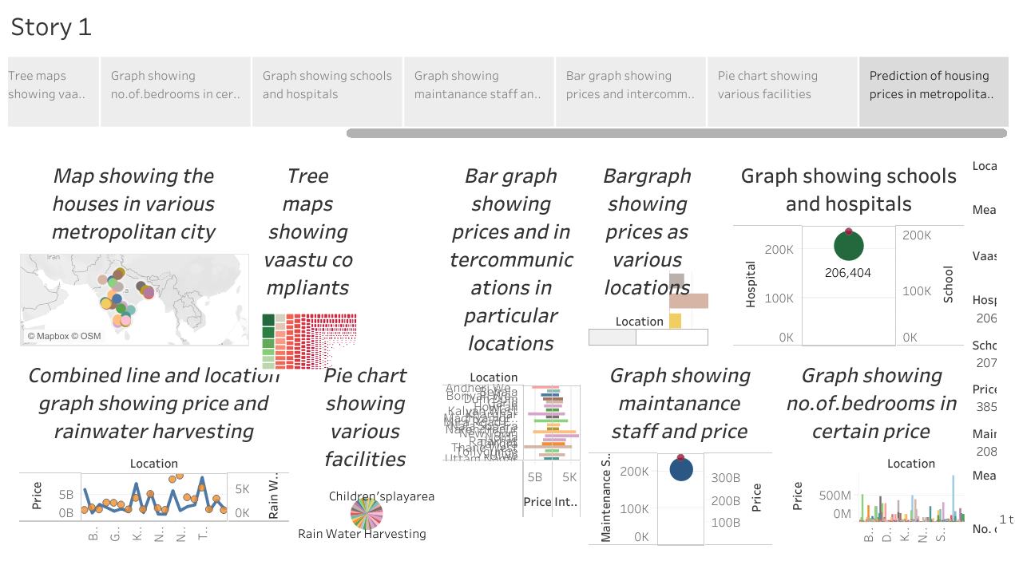

**7.ADVANTAGES**

* More job opportunities
* Greater variety of entertainment and dinning options
* More public transportation options.
* The advantages include access to better schools , more job opportunities.
* More mobility
* Limited financial obligation.
* Renovating choices
* Pride of ownership.

**DISADVANTAGES:**

* Lifestyle limitations.
* No equity growth or store of value
* Crimes such as murder , kidnapping, crimes against women , senior citizens and cyber-crimes

are the biggest problems .

* It’s expensive. The cost of living is high in most big cities , which can make ends meet if you don’t have a high-paying jobs.
* Because of larger populations , cities can have high level of pollution , including noise pollution.

This could be damaging to your health in the long term.

* If you have pets you may find it harder to find a place to live that allows them. It may also

be harder to find a place to walk a dog or enjoy outdoor space with them.

* It doesn’t predict future prices of the houses mentioned by the customer.
* Expensive property leads to an increase in rents – because rented housing is a substitute forowner – occupation . This reduces geographical mobility.

**8.APPLICATIONS:**

* It offers limitless social potential for making friends and networking.
* It foster personal bonds.
* Hospitals are outfitted with cutting- edge technology, a group of elite medical professionals or first rate services.
* High – speed internet access in the form of Fiber and 5G.Lower risk to entrepreneurship.

**9.CONCLUSION**

* ***This paper aims to examine the dynamics of house prices in metropolitan cities in an emerging economy.***
* ***The purpose of this study is to characterize the house price dynamics and the spatial heterogeneity in the dynamics.***

**7.FUTURE SCOPE**

Prediction house prices are expected to help people who plan to buy a house so they can know the price range in the future , then they can plan their finance well.

In addition , house price predictions are also beneficial for property investors to know the trend of housing prices in a certain locationF